Annex B

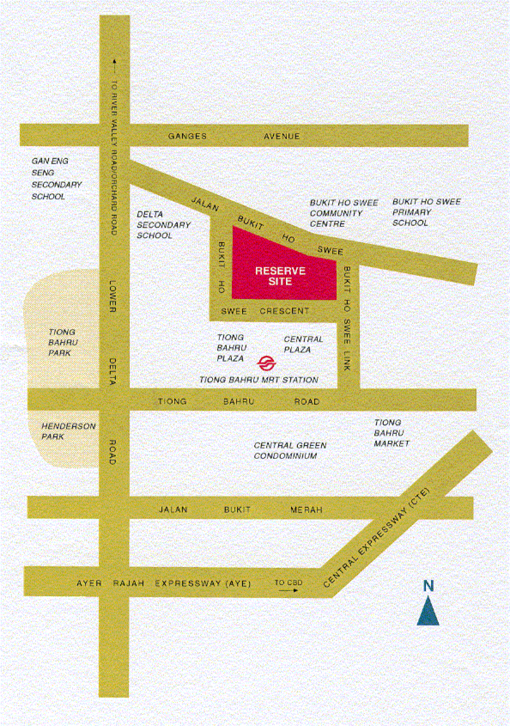

http://www.sla.gov.sg/announcement/Annex%20B.html

